**360 CAMERS DATA**

**About**

**Specializing in CCTV CAMERS ServicesAND SECUTITY**

**Protect 360 security service**  is a thorough commercial and residential security device like cctv camera, biomatric system, VDP (Video Door Phone) or other Surveillance system devices provide skilled security alerts, productive alarm checking, rapid reaction and diligent security guard workers through the entire **pune and pcmc like hinjewadi, chakan, pimple saudagar all sectors, along with local areas of India.**

**Mobile Device Supported**

* **Easy Remote control**
* Reduce Security Costs.

**You Will Love It.**

**Works & benefit**

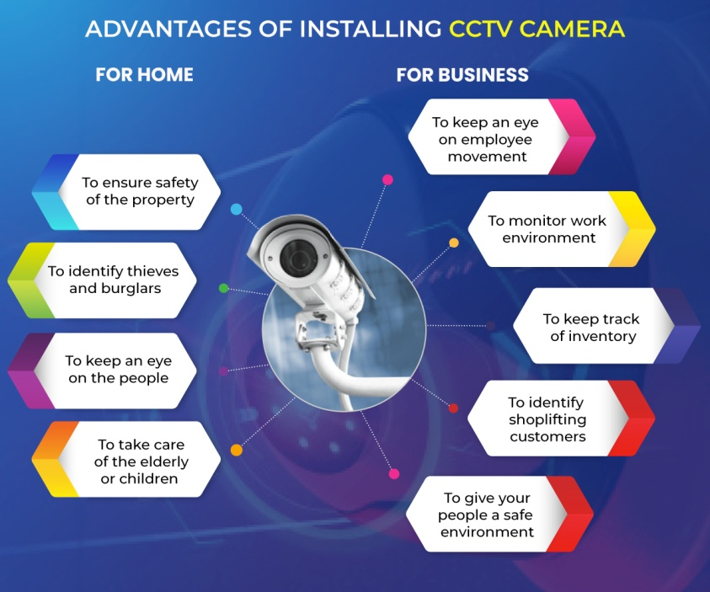

**Testimonial**

**Sujal rajput**

the seller is polite and good with customer. he gives proper information about components and the good quality products are selled by him. the best electronic components store i ever have seen

**pradeep bodker**

Very nice shop and superb service .  
Almost all latest stuff in camera and security system available at reasonable rates. Also any queries regarding any camera system is sorted immediately and everyone in the staff are very helpful and technically very knowledgeable

**Avi**

One Shop Stop for all your CCTV related equipment ....  
Owner is quiet Knowlegable on all the Tech fronts .. will definately buy more products in near Future

**Deepak jadhav**

Best place to find all your needs and consumer satisfying products

**Brands name**

1. **Hikvision**
2. **Cp plus**
3. **Godrej**
4. **Samsung**
5. **Sony**
6. **Honeywell**
7. **bosch**